Set up ai automation process:

The email inbox rotation program is in effect. We are using:

- n8n to take in Hubspot intent companies and filters
- Clay to enrich the companies with contact info
  - AI personalization/PainPoint
  - Update Hubspot properties
  - Send to Amplemarket
- Amplemarket to enroll in sequences. With multiple inboxes set up for each rep (only James for now, with Nick's inbox handling the outreach for Patrick/NorthEast leads for now)

Good news though! We currently have a 55% open rate from the AmpleMarket Sequences:

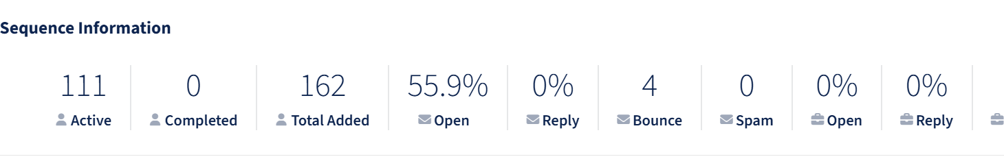

With just 100 leads though, so hopefully with volume, we get more replies.

